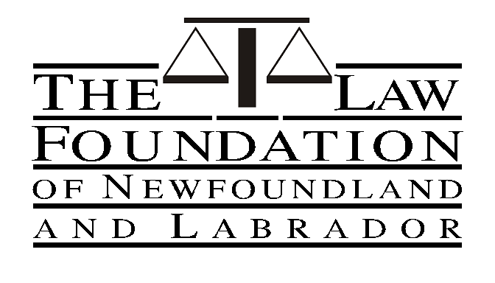

LAW FOUNDATION OF NEWFOUNDLAND AND LABRADOR

LAW SCHOOL SCHOLARSHIPS APPLICATION FORM

Date:

Applicant’s Name (in full):

Mailing Address:

Permanent Address:
(if different from above)

Email Address: ______________________________________________

Telephone: Present: ______________Home:

I hereby make application for the Law Foundation of Newfoundland and Labrador Scholarship for the academic year 2020/2021.

Other Scholarships for which application has been made:

Other Scholarships I would be eligible to receive:

…/2

- 2 -

I was born at in the Province of

and my date of birth is

References: I have arranged for references from the following two persons (at least one of whom has taught me at University) for an assessment of my qualifications, character, etc., which I have requested they send directly to the Foundation:

NAME ADDRESS

1.

2.

Accompanying this application are:

1. Certified evidence of the courses of study I have pursued, together with my grades.

2. A copy of my LSAT result.
NOTE A: Submittal of your application need not await receipt of your result if it is not yet available. When you receive online the Candidate Report with your name and LSAT score from Admission Test Services forward a copy to the Law Foundation. A photocopy will suffice.
NOTE B: Notwithstanding McGill University does not require Law School applicants to complete the Law School Admission Test, an applicant who wishes to apply for a Law Foundation of Newfoundland and Labrador Law School Scholarship must have an LSAT score to accompany their application documents.

3. A statement of my general interests and activities.
NOTE: A statement of general interests and activities is not a resume. Though a resume is not necessary, if an applicant wishes to submit a resume as part of their statement of interests and activities, they may do so.

…/3

- 3 -

4. Sworn Affidavit as to residency.

Definition as to residency:

As a general rule you are considered to be a resident of a province or territory in which your parents, guardians, foster parent or a sponsor live at the time you apply or in which the family home is being maintained, even if one parent works in another province or territory. If you are married or qualify as independent, you are considered a resident of the province in which you last lived for at least 12 consecutive months, excluding periods engaged in post-secondary education.

Signature of Applicant

MAIL APPLICATION AND ENCLOSURES TO:

Law Foundation of Newfoundland and Labrador
P.O. Box 5907
St. John’s, NL
A1C 5X4

Street address: 49-55 Elizabeth Avenue, Second Floor, St. John’s, NL

Telephone: (709) 754-4424
Facsimile: (709) 754-4320
Website: www.lawfoundationnl.com
E-mail: lfnl@lawfoundationnl.com

LAST DAY FOR RECEIVING APPLICATIONS IS MAY 1, 2020

…/4

- 4 -

DOMINION OF CANADA

TO WIT:
AFFIDAVIT

I, , of in the
(Applicant’s Name) (City/Center)

Province of MAKE OATH AND SAY AS FOLLOWS:

- THAT I am a resident of the Province of Newfoundland and Labrador within the definition as contained in the application for the Law Foundation Scholarship attached hereto.

SWORN TO at
(City/Center)

in the Province of

this day of

A.D., 20____, BEFORE ME:

(Applicant’s Signature)

(Commissioner for Oaths, Notary
Public, or Barrister, Solicitor)

